Deng Style Acupuncture & Pulse Diagnosis
Workshops & Coaching Practicum
Daniel Deng is offering an insight into his unique and effective acupuncture and pulse diagnosis methods through a series of 3 full day English language workshops, 10 sessions of coaching practicum.
Learn first-hand the unique Deng Style Acupuncture Method developed through more than 30 years of clinical experience from the expert himself.
Daniel will take you through the theoretical basis of his acupuncture and pulse diagnosis methods and answer your many questions about it;
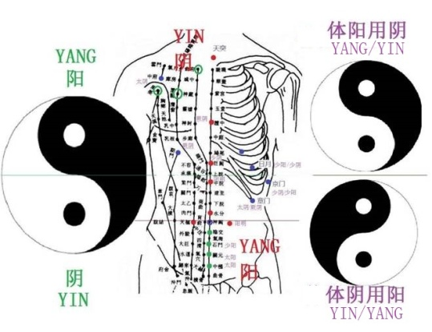
You get to be Daniel's personal assistant in his clinic and observe him put his method of acupuncture into practice on his patients. you get to watch the expert in action.
The content of the three workshops include:
1: The using of Yin/Yang concept in the context of acupuncture
2: The theoretical underpinnings of the Deng Style Acupuncture & Pulse Method
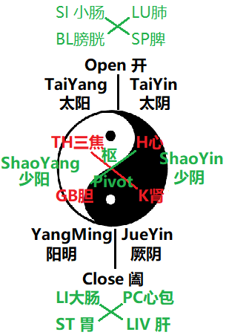
3: Deng Style Pulse diagnosis method, the relationship to point selection and evaluation of treatment effects
4: Specific acupuncture tonification and reduction techniques
5: Body evidence for acupuncture
6: The Deng Mirror X Therapy
7: Jing Luo and head Micro-system Therapy
8: LuoMai therapy
9: Acupoint Array Balance Method
10: ShenQue 3 Axis Balance Method
11: Four limb Balance Method
12: Individual Outstanding Pulse Balance Method
13: NeiJing Opening, Closing and Pivot Method
14: Clinical protocols for effective point selection
15: Practice of the Deng Style Acupuncture on fellow workshop participants

Deng Style Acupuncture & Pulse Diagnosis 3 days workshop will be on：
08/12, 09/12, 16/12/2018. From 9.30AM to 5.00PM.
18 CPD for AACMA, ATMS.
Venue: Acupuncture & Herbs Daniel Deng & Associates
Level1, 6/62-64 Cronulla St, Cronulla NSW 2232
Please ring me on 0431800200 or email me at tcmdeng@yahoo.com.au

